**For the first time, AMD outperforms Intel in terms of market capitalization**

AMD's star continues to rise

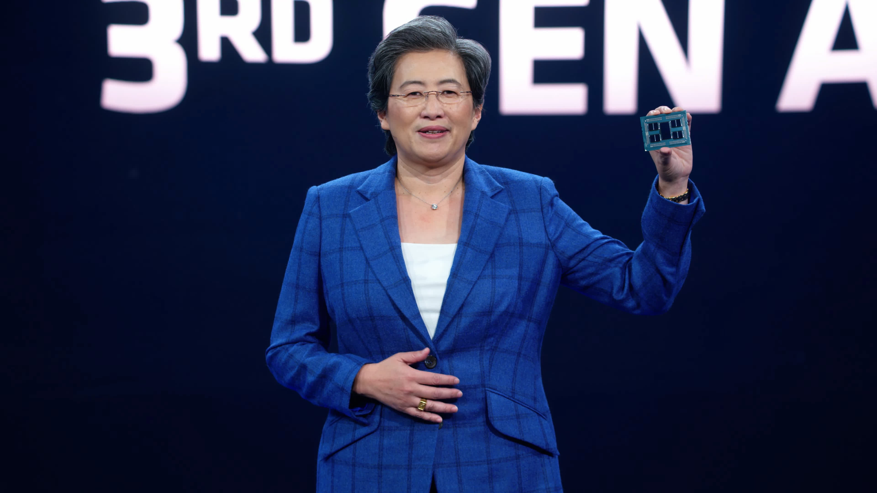

So, what exactly happened? Since the release of its initial Zen architecture in 2017, AMD's fortunes have improved dramatically, albeit few would have predicted it would reach this milestone in such a short period of time: AMD now has a greater market cap than rival Intel for the first time ever.

The $49 billion all-stock buyout of Xilinx by AMD on Monday, 15 months after the deal was announced, boosted AMD's market cap dramatically. The purchase was worth $35 billion when AMD first announced its plans, but it was worth $40 billion once the stock values of the firms changed.

The deal is one of the largest in tech history, behind Dell's $67 billion purchase of EMC in 2015 and Microsoft's recent $68.7 billion purchase of Activision Blizzard.

The purchase meant that for every Xilinx share a shareholder owned, they would receive 1.7234 new AMD shares, transforming 248.38 million Xilinx shares into 428 million AMD shares. As a result, according to Tom's Hardware, AMD's entire share count jumped to 1.628 million.

AMD's market valuation jumped to $197.75 billion as a result of the increase in shares, surpassing Intel's $197.24 billion by $51 million.

AMD has had a nice month so far. In addition to surpassing Intel's market capitalization, Team Red also controls a record 25.6 percent of the overall x86 market. It also recovered in January's Steam survey after a drop in the number of people utilising its CPUs in December. Furthermore, its stock is worth $121.47, which is more than double Intel's $48.44.

Of course, Intel still controls three-quarters of the x86 market, and its CPUs are present in 70% of Steam poll participants' computers. It also generates more income and profit than AMD, not to mention having its own fabrication facilities. But AMD is chipping away at the blue team's lead, and when the all-new Zen 4 arrives later this year, things will get much more intriguing.